Kapadia, Hasan

Hk42@hw.ac.uk

H00289018

Robotics

Automation in Robotics

**Introduction**

Automation has been around for decades but due to the sudden surge of high technological advancements, this era is significantly different compared to the automation in the industrial age.

Robots are now able to perform complex tasks which need more processing power than what machines needed in the past such as landing planes, performing surgeries and manufacturing products. This has led to many helpful uses of automation but also has been harmful in certain aspects.

With the rise of automated labour where will this technology lead us, is it beneficial for us or will it affect our lives in a bad way?

**Body**

In the past, this ‘automation’ was focused on the machines making work easier for us. Although this led to many jobs being taken over by machines, it also led to the creation of many new jobs for the workers, leaving the hard labour for the machines.

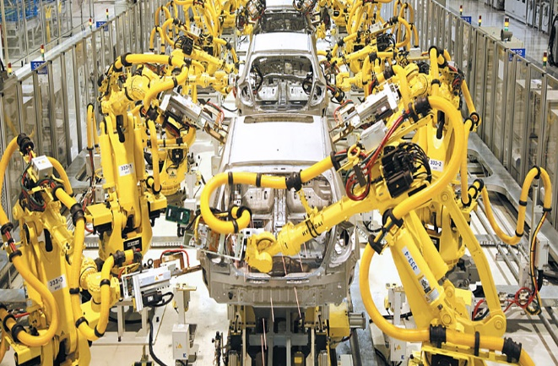But at this time and age, things are different. With robots being made with artificial intelligence and self-learning capabilities integrated into them. They are rapidly learning how to do complex tasks and are taking over jobs faster than new jobs can be created. “The robots haven’t just landed in the workplace-they’re expanding skills, moving up the corporate ladder, showing awesome productivity and retention rates, and increasingly shoving aside their human counterparts.” (Ford, 2014) This has led to an increase in unemployment as many workers are being replaced by robots as it is more cost efficient for the company as robots do not need to rest, need any salary or insurance and are more productive than humans.

Figure 1: Robotic Assembly Plant (International, 2016)

Figure 1 depicts an assembly line for manufacturing cars. As you can see 75% of the process for manufacturing cars has been taken over by robots. Although they may be cost-efficient and more productive they are very expensive to make and operate and still do need some human intervention. But this could change in the foreseeable future with technological advancements being made every day.

“Developments in robotics and AI are setting the stage for machines to replace millions of jobs, and it isn’t just the manufacturing sector being threatened. Thanks to increasingly sophisticated and efficient robots, even things like hotel room service, cashiers, and taxi drivers can potentially be automated over the next 10 years.” (Workopolis, 2017) Despite the fact robots can do a lot of jobs better than us there are many jobs robots will not be able to replace humans in. Such as doctors, professors, therapists, and chefs as robots are robots. artificial machines created by humans they do not feel empathy, cannot properly interact with humans, and cannot present dishes true they might be able to cook but they cannot present the dish properly.

Humans and robots have a complicated correlation, one cannot live without the other. As we need robots in our lives to make life itself easier for us and robots need us to make it learn and develop or even for repairs/maintenance which it cannot do on its own.

**Where will this technology lead us?**

A close up of text on a white background

Description generated with very high confidenceAs this technology continues to grow there is inevitably going to be an increase in automated labour. From a company’s point of view, it will prove as a benefit with reduced costs and increased profits, but this could also lead to a phenomenon caused by automating labour (Acemoglu & Restrepo, 2018). As jobs are taken over by machines and costs are reduced, with the increase in production and demand this could create new tasks and it would prove unnecessary and non-profitable to employ machines for these tasks thus jobs being created for manual labourers.

As shown in Figure 2 the trillion-dollar company Amazon, which over the last couple of years has increased its manual and automated workforce by the thousands, with automated labour being increased from 1,400 to 45,000. With this increase in automated labour, it has not affected Amazon's manual labour which is also being steadily increased over the years.

Figure 2: Headcount amazon headquarters

**Impact of Automation**

Though automation has taken away many jobs, it has provided us with a new understanding of how productivity can be maxed out and product quality be increased, it has also reduced hours worked of factory workers by almost 60% as machines can work 24/7 and can cover up the remaining hours and keep the product quality to the highest degree thus maximizing productivity without any effect on product quality. (Groover, n.d.)

With Automation being used like this it would prove beneficial for humanity as not only production is increasing, the quality of products is being increased and new jobs are being created.

The dispute if automation is a good thing or not is still raging on with some saying that automation cannot be declared to be useful just by the increase in productivity, it can only be

proven useful if the increase in productivity is backed up with an increase in sales and decrease in expenses. (Mayville, 2017)

Many automobile manufacturers have also started using AI or even automation of certain tasks such as driving with driverless cars being created and, on the rise, these cars have shown to be useful as the percentage of incidents on the roads have decreased. But there are drawbacks to this technology as it is part of this ever-growing technological world. It can be hacked by hackers if the security systems built in the cars are not advanced enough to stop them and if a few systems are compromised it could lead to fatal injuries or even death.

**Conclusion**

Automation has proven in many cases to be beneficial to us even taking the drawbacks into the question the good outweighs the bad. But as day by day advances are made there could be viruses made to get into these machines and take them over and if that is successful it could lead to many issues being made it could be a global catastrophe.

This technology still has a lot of time until it can be perfected. Many things can change until that time comes it could be that by then that all the primary and secondary sector is replaced by machines and us humans are focused in the tertiary sector.

Until that time comes as things are going right now is perfect with a healthy balance between automation and manual laborers.

# References

Acemoglu, D. & Restrepo, P., 2018. *Artificial Intelligence, Automation and Work,* Boston: MIT | Boston University.

Ford, M., 2014. *The rise of the Machines: The Future has Lots of Robots, Few Jobs for Humans.* [Online]   
Available at: https://www.wired.com/brandlab/2015/04/rise-machines-future-lots-robots-jobs-humans/#article-comments  
[Accessed 23 October 2018].

Groover, M. P., n.d. *Automation: Advantages and disadvantages of automation.* [Online]   
Available at: https://www.britannica.com/technology/automation/Advantages-and-disadvantages-of-automation  
[Accessed 27 October 2018].

International, M., 2016. *Robotics & Automation,* s.l.: Moltec International .

Kessler, S., 2017. *The optimist’s guide to the robot apocalypse.* [Online]   
Available at: https://qz.com/904285/the-optimists-guide-to-the-robot-apocalypse/  
[Accessed 21 October 2018].

Workopolis, 2017. *10 high-paying jobs that will survive the robot invasion.* [Online]   
Available at: https://careers.workopolis.com/advice/10-high-paying-jobs-will-survive-robot-invasion/  
[Accessed October 2018].